LAB-1 REPORT

***ScrumDo***

1. First step for creating a srumDo account is to visit www.scrumDo.com and Sign up by filling the details as below.

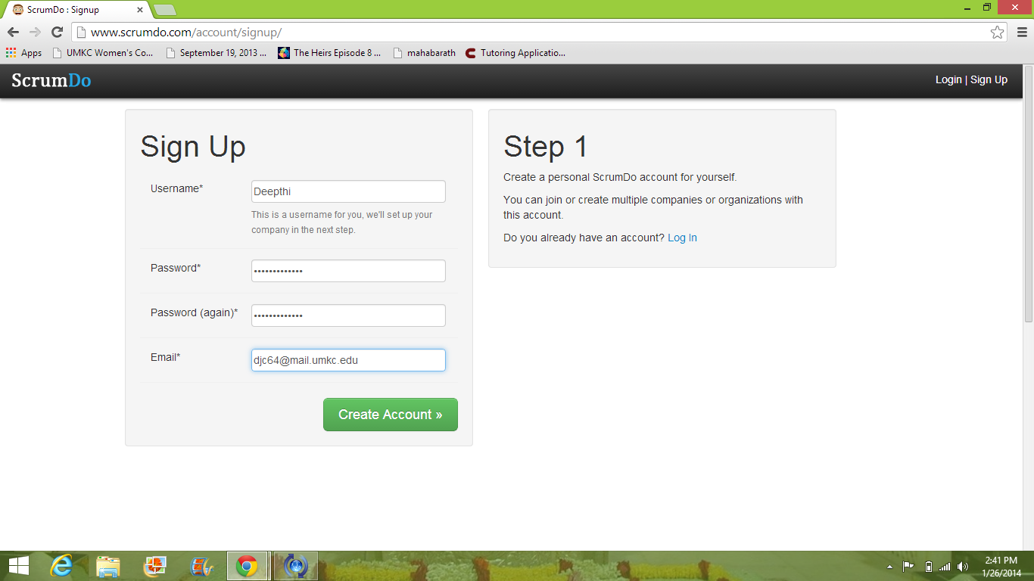

2. Specify an organization name

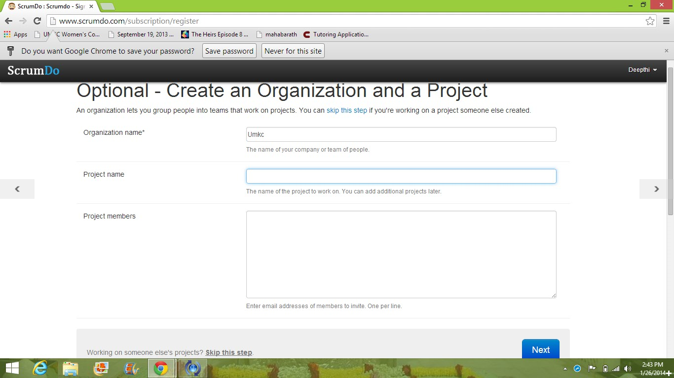

3. Create a new iteration

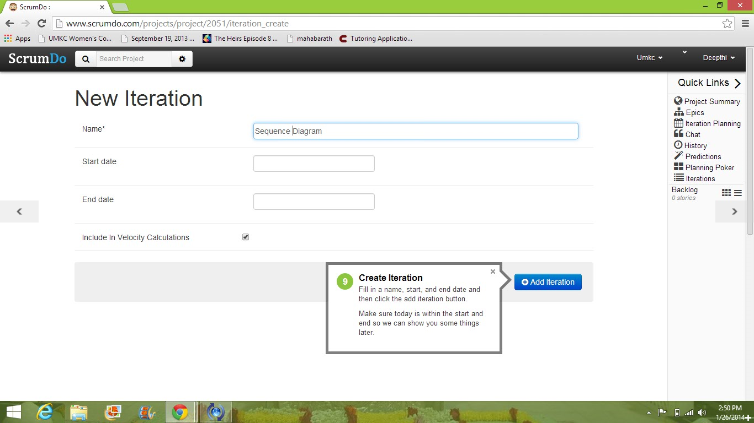

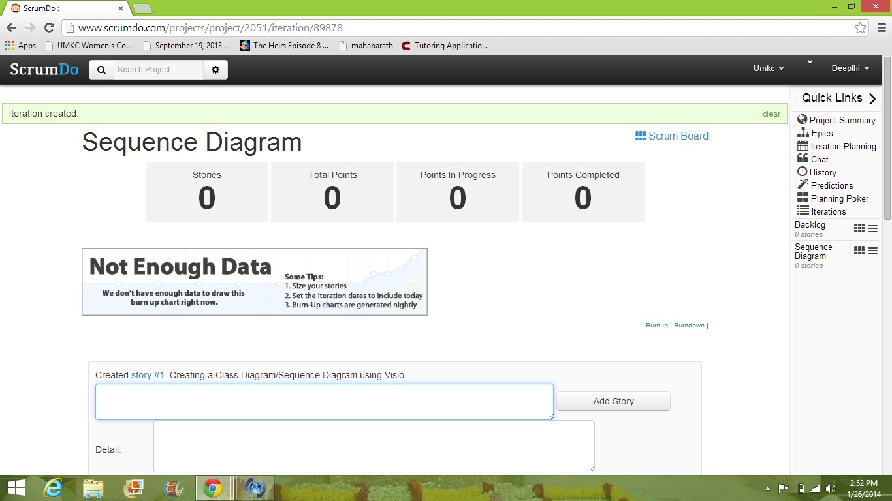

4. Create a project name. Under the organization label click on project and we can create a new project.

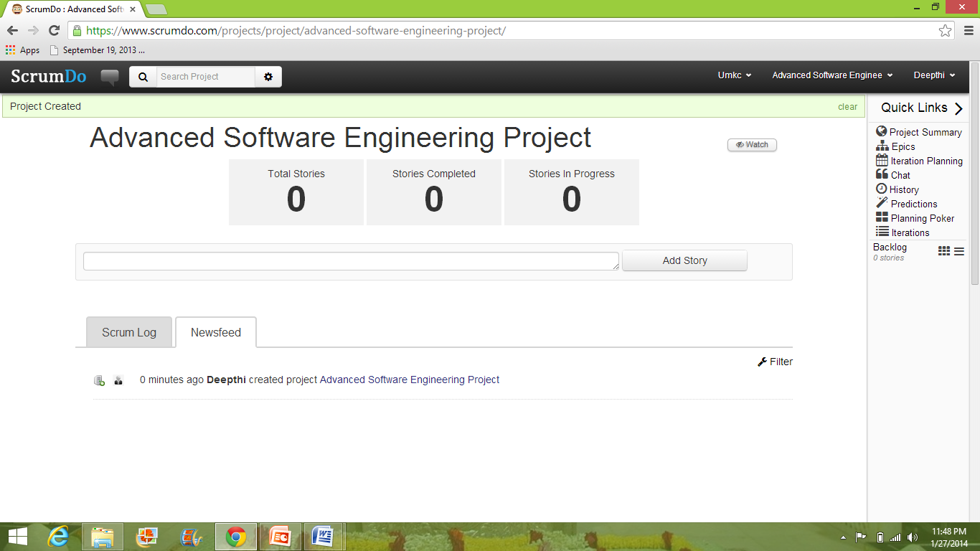

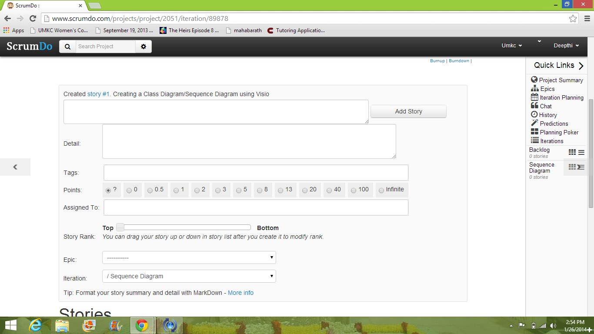

***GitHub***

1. First step for setting up a GitHub account is go to www.github.com and sign up. After that sign in with the required details.

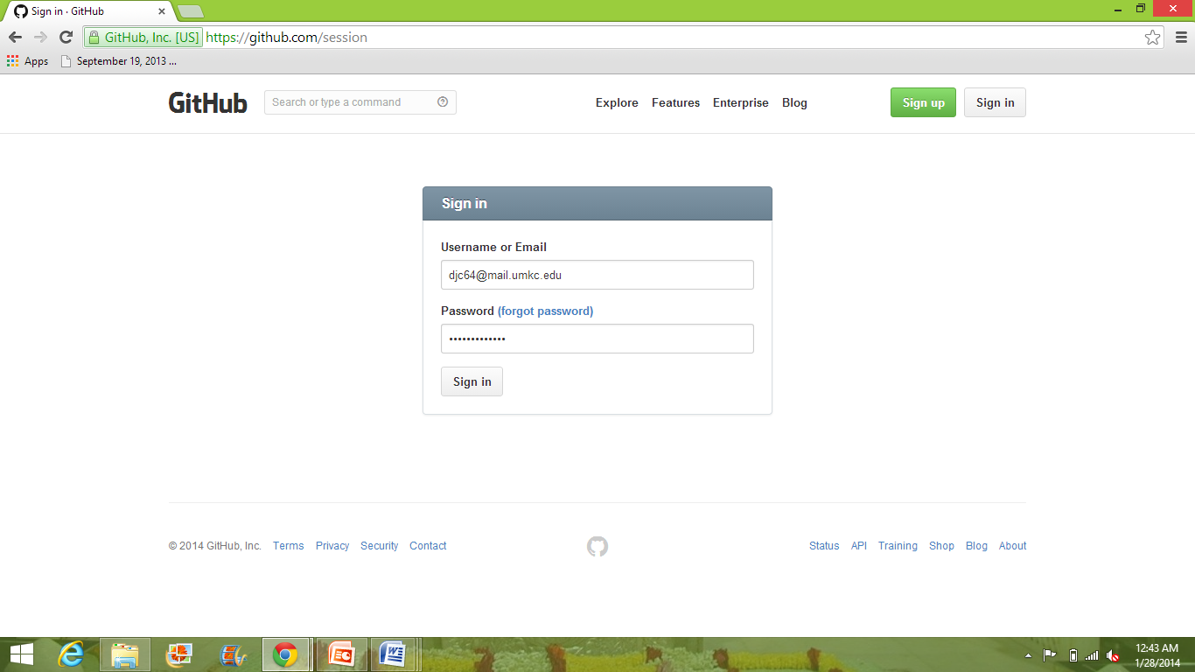

2.Create a new Repository name. For example: Demo Project

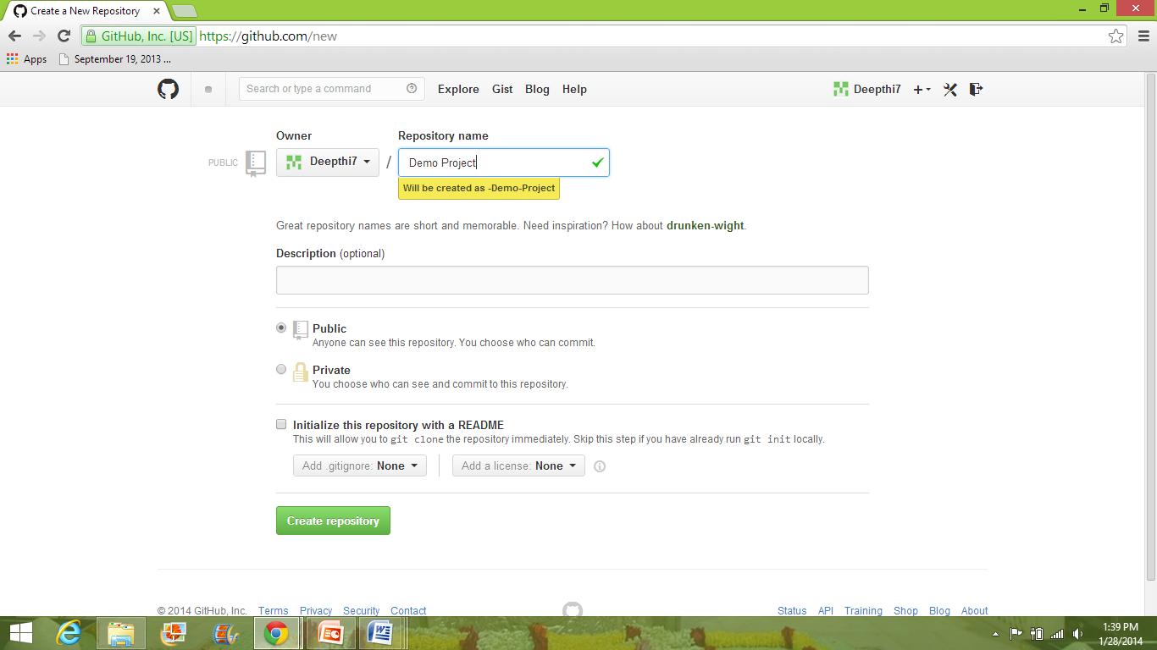

3. Now download the GitHub to your desktop and login. We can access the repository created in the Remote GitHub account in local GitHub by cloning.

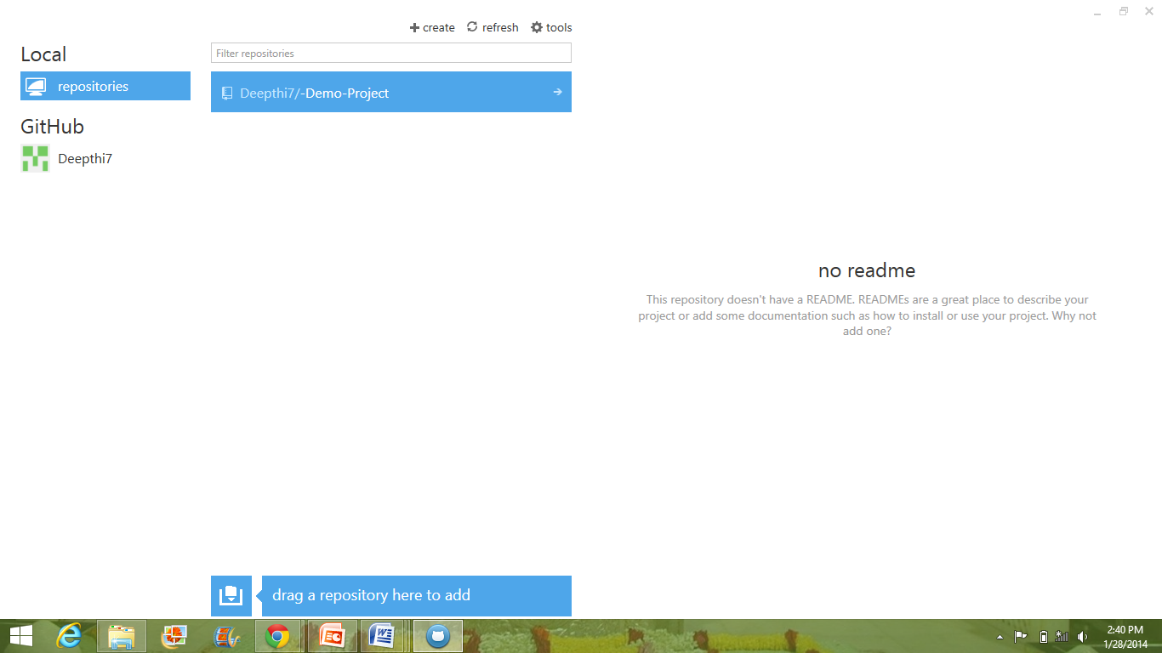

4. We can add required folders to the local repository accounts in the documents folder.

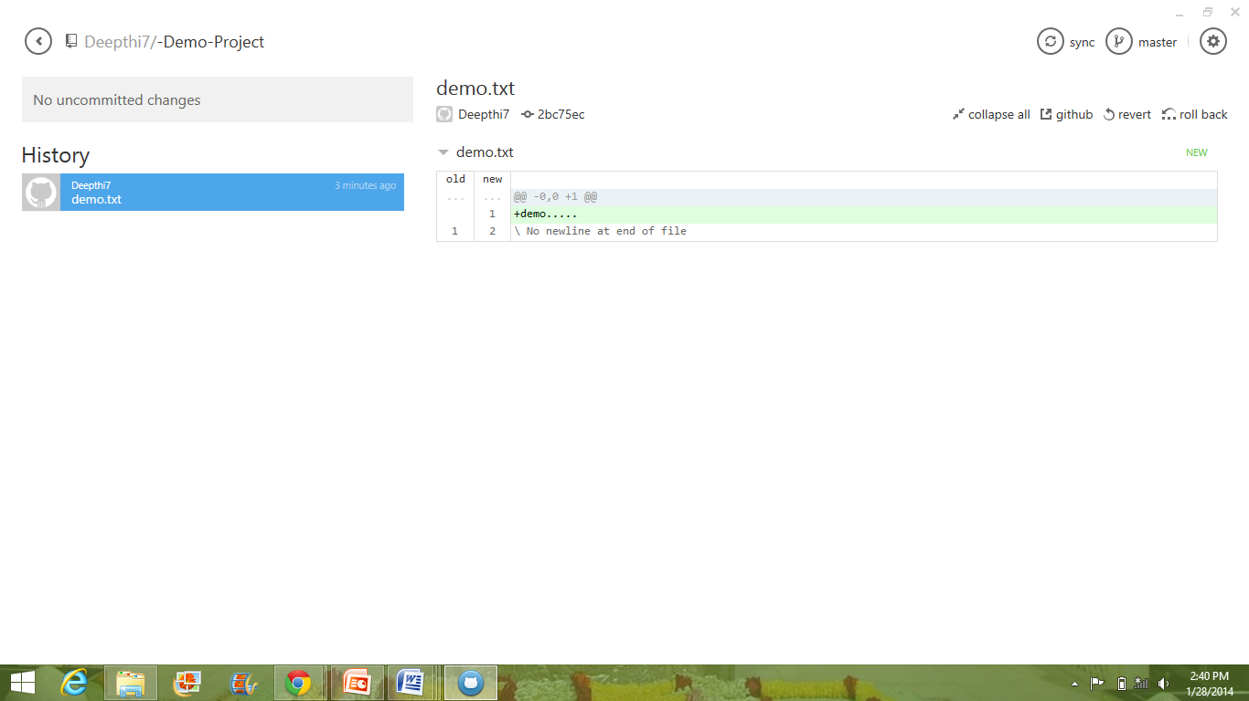

5. In order to view the created folders in remote account we need to click the commit option and then sync.

